June 26, 2024
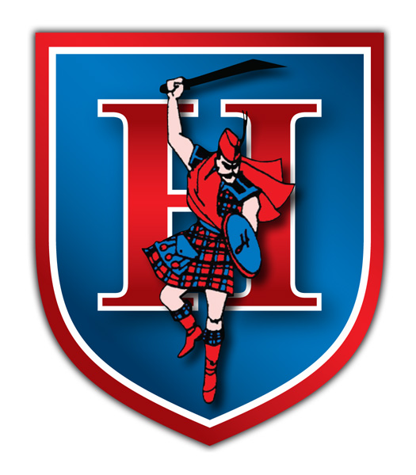

Highland Local Schools

Job Posting

High School Health and Physical Education

Anyone interested in the above position please notify:

Chad Carpenter, High School Principal

On or before noon July 9th, 2024

